PROJECT REPORT
Date | 18 February 2026
Team ID | LTVIP2026TMIDS57846
Project Name | Civil Engineering Insight Studio

1. INTRODUCTION

1.1 Project Overview
The Civil Engineering Insight Studio is an AI-powered web application that analyzes images of civil engineering structures and automatically generates detailed technical descriptions.
The system uses the multimodal capabilities of Gemini to interpret images and provide structured insights such as:
- Structural type
- Materials used
- Dimensions (estimated)
- Construction methods
- Structural components
- Engineering challenges
The application is deployed using Streamlit, enabling real-time user interaction.

1.2 Purpose
The purpose of this project is to:
- Reduce manual effort in structural documentation
- Improve consistency in engineering reports
- Support project monitoring
- Assist civil engineers in decision-making

2. IDEATION PHASE

2.1 Problem Statement
Civil engineers often manually analyze construction images to describe structural components, materials, and progress. This process is:
- Time-consuming
- Subjective
- Prone to inconsistencies
There is a need for an automated AI-based tool to generate reliable structural descriptions from images.

2.2 Empathy Map Canvas

Target Users:
- Site Engineers
- Project Managers
- Structural Consultants
- Construction Supervisors

Empathy Map
Think | Feel
Need accurate reports | Overloaded with documentation work
Want quick structural analysis | Frustrated by manual effort
See | Do
Construction sites daily | Take photos for documentation
Structural components | Prepare reports manually

2.3 Brainstorming
Ideas considered:
- Manual annotation system
- Rule-based detection
- AI-based image interpretation
- Integration with generative AI for structured reporting
Final idea: Use Gemini Vision model for multimodal image + text analysis.

3. REQUIREMENT ANALYSIS

3.1 Customer Journey Map
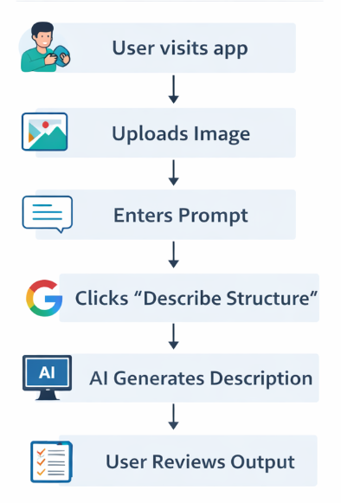

3.2 Solution Requirement

Functional Requirements
- Upload image (JPG/PNG)
- Accept user prompt
- Analyze structure using AI
- Generate detailed description
- Display output clearly

Non-Functional Requirements
- Fast response time
- Secure API key storage
- User-friendly interface
- Reliable AI processing

3.3 Data Flow Diagram (DFD)

Level 0 DFD
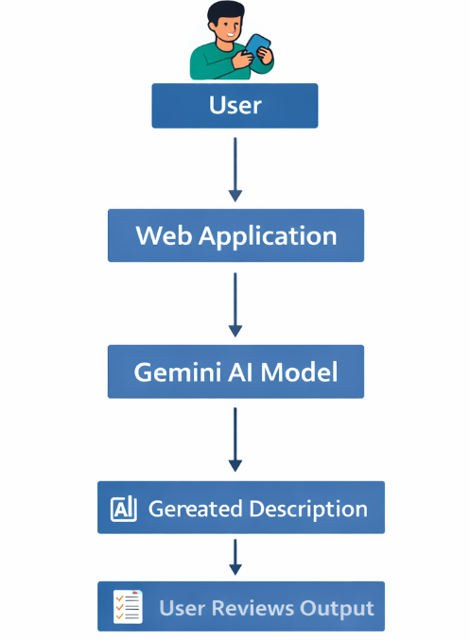

3.4 Technology Stack

Layer | Technology
Frontend | Streamlit
Backend | Python
AI Model | Gemini
Environment | python-dotenv
Image Processing | PIL

4. PROJECT DESIGN

4.1 Problem Solution Fit
Problem | Solution
Manual reporting | Automated AI description
Inconsistent analysis | Structured AI-generated output
Time-consuming documentation | Instant image interpretation

4.2 Proposed Solution
The proposed system:
- Accepts image input
- Sends image + prompt to Gemini Vision model
- Generates structured structural analysis
- Displays insights on web interface

4.3 Solution Architecture
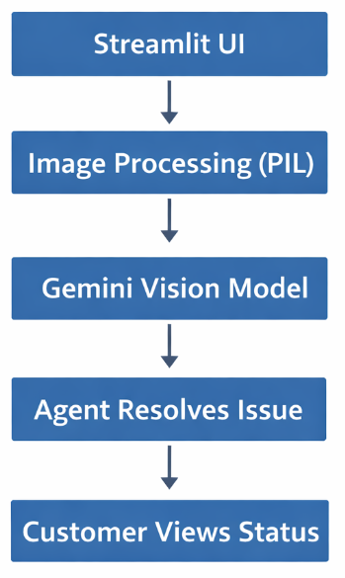

5. PROJECT PLANNING & SCHEDULING

5.1 Project Planning
Phase | Activity | Duration
Phase 1 | Requirement Analysis | 2 Days
Phase 2 | API Setup | 1 Day
Phase 3 | Model Integration | 3 Days
Phase 4 | UI Development | 2 Days
Phase 5 | Testing | 2 Days
Phase 6 | Documentation | 2 Days

6. FUNCTIONAL AND PERFORMANCE TESTING

6.1 Performance Testing
Test Case | Result
Image Upload | Success
AI Response Generation | Success
Invalid File | Handled
No Image Upload | Warning Displayed
Response Time | Within acceptable limits
System successfully generates structured descriptions for various civil structures like buildings and bridges.

7. RESULTS
The system successfully:
- Identified construction materials
- Recognized structural components
- Documented project progress
- Generated structured engineering descriptions

7.1 Output Screenshots

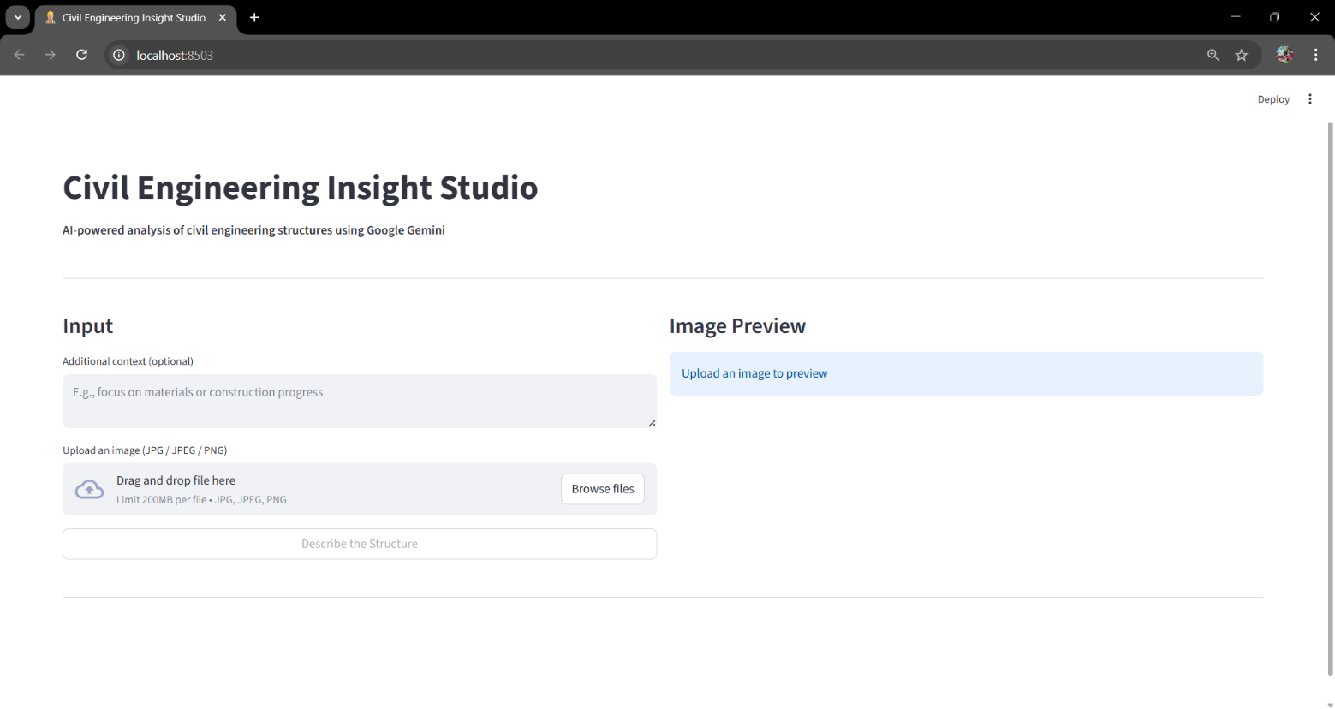

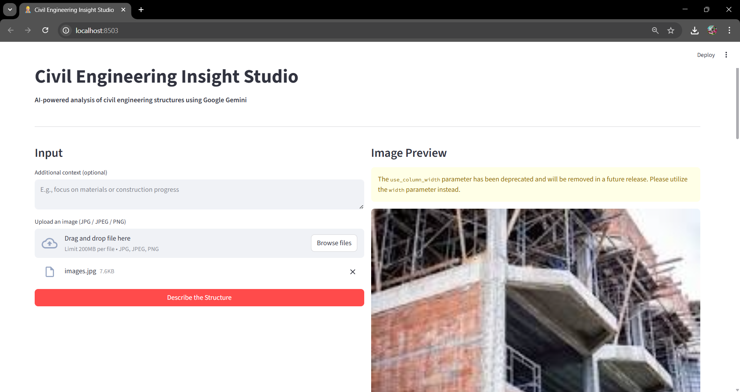

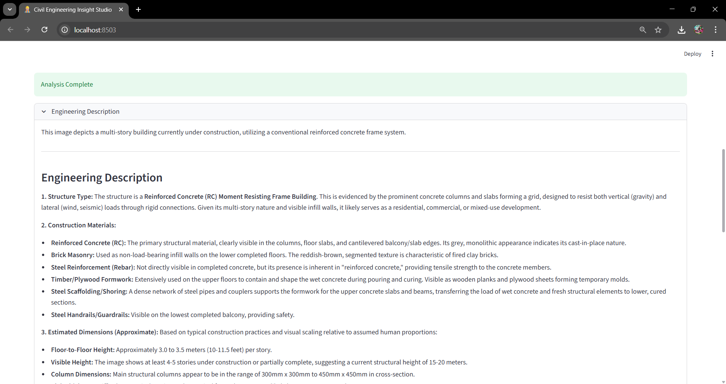

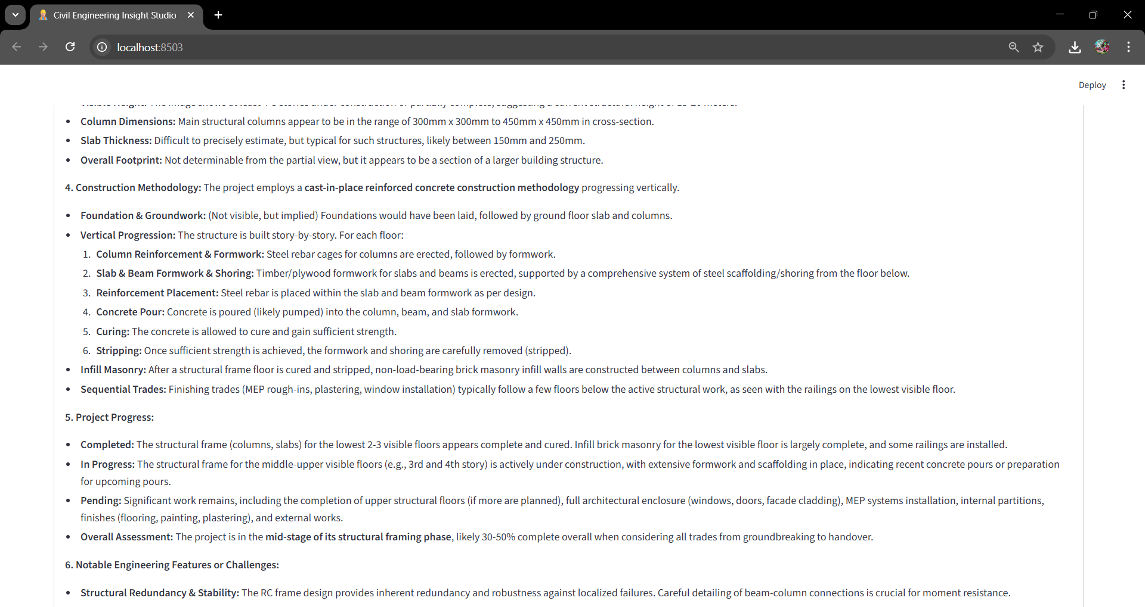

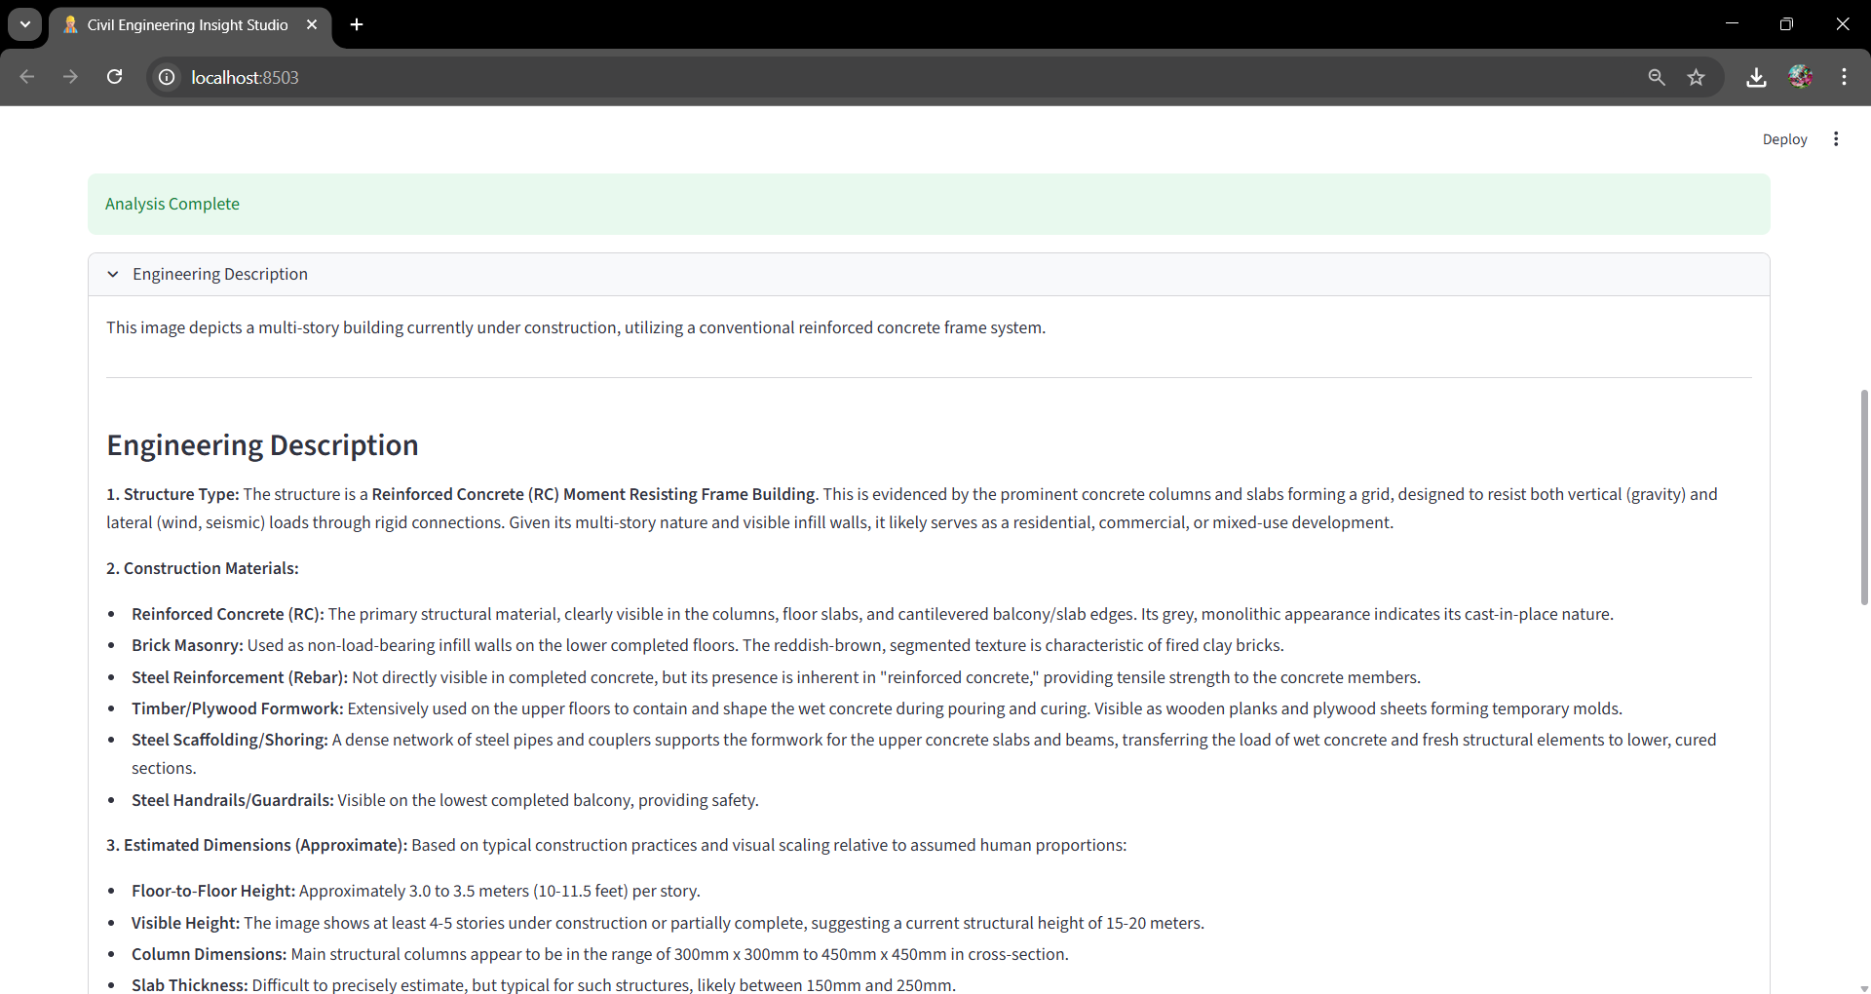

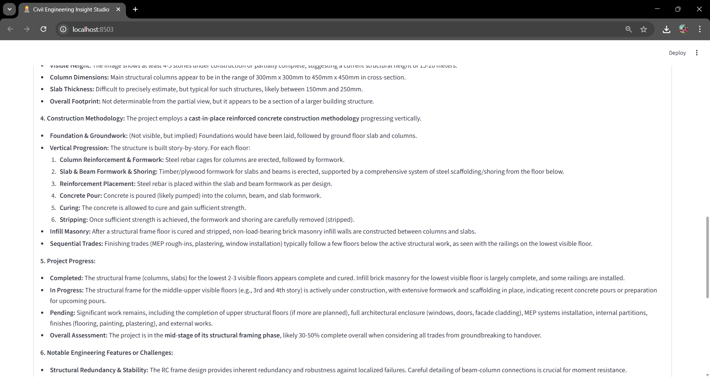

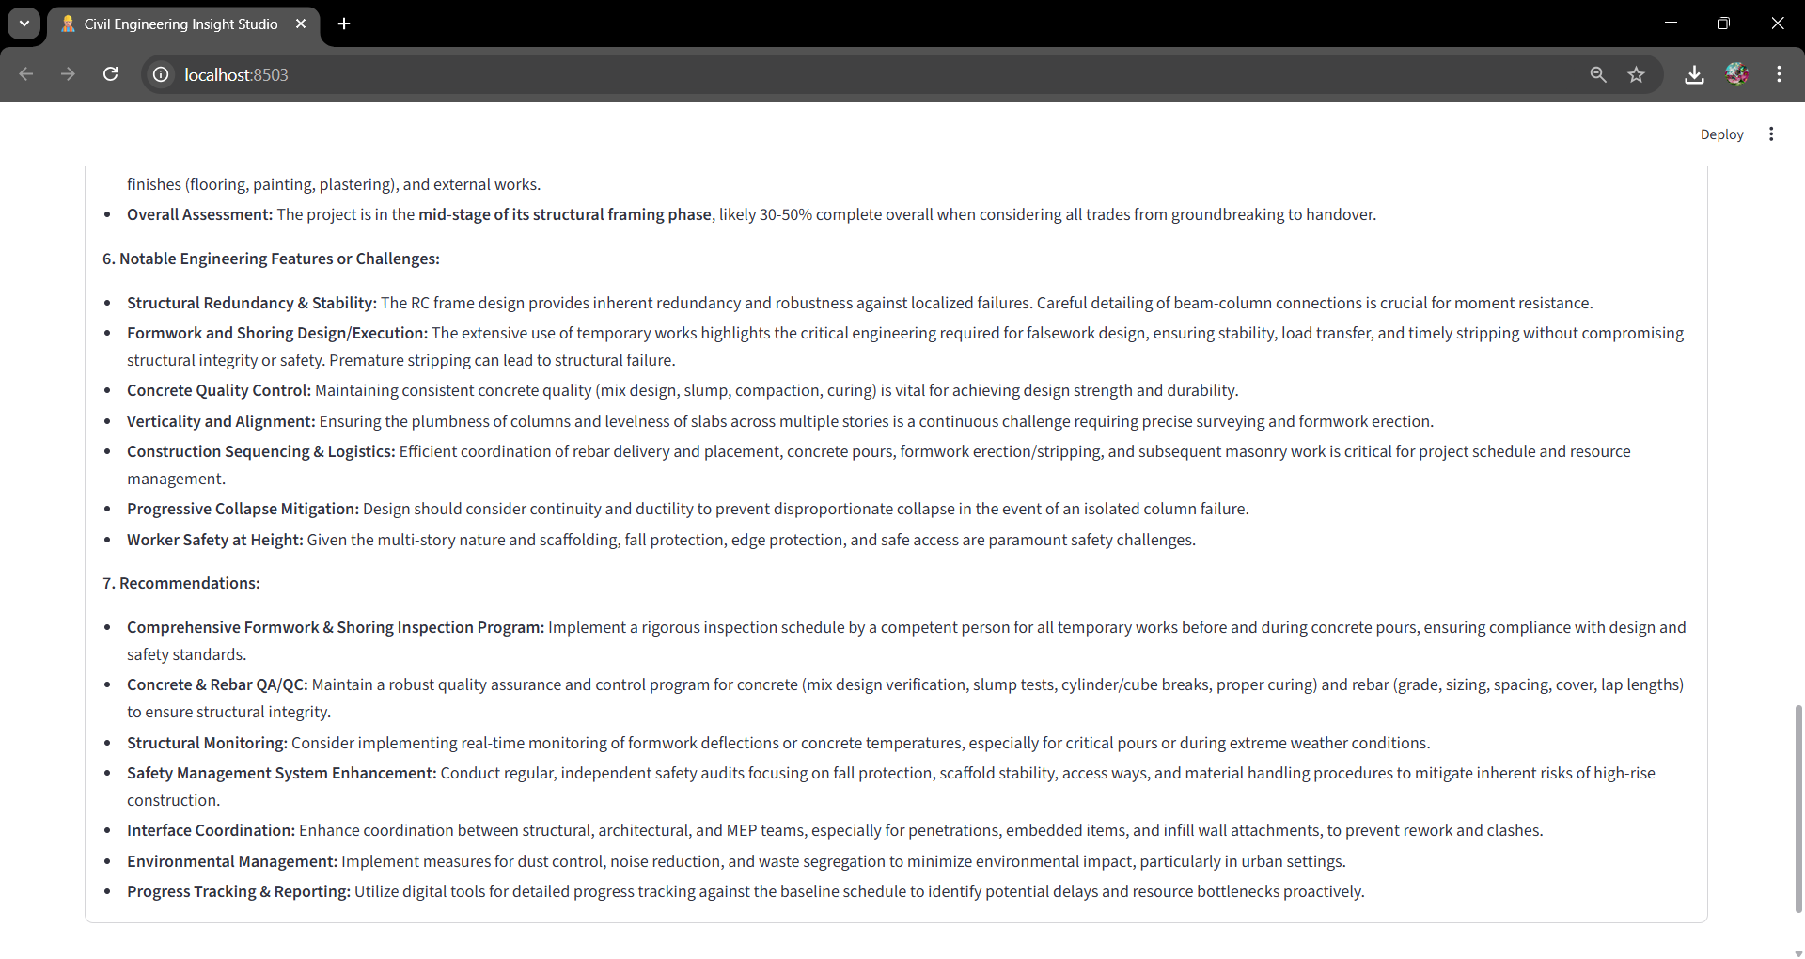

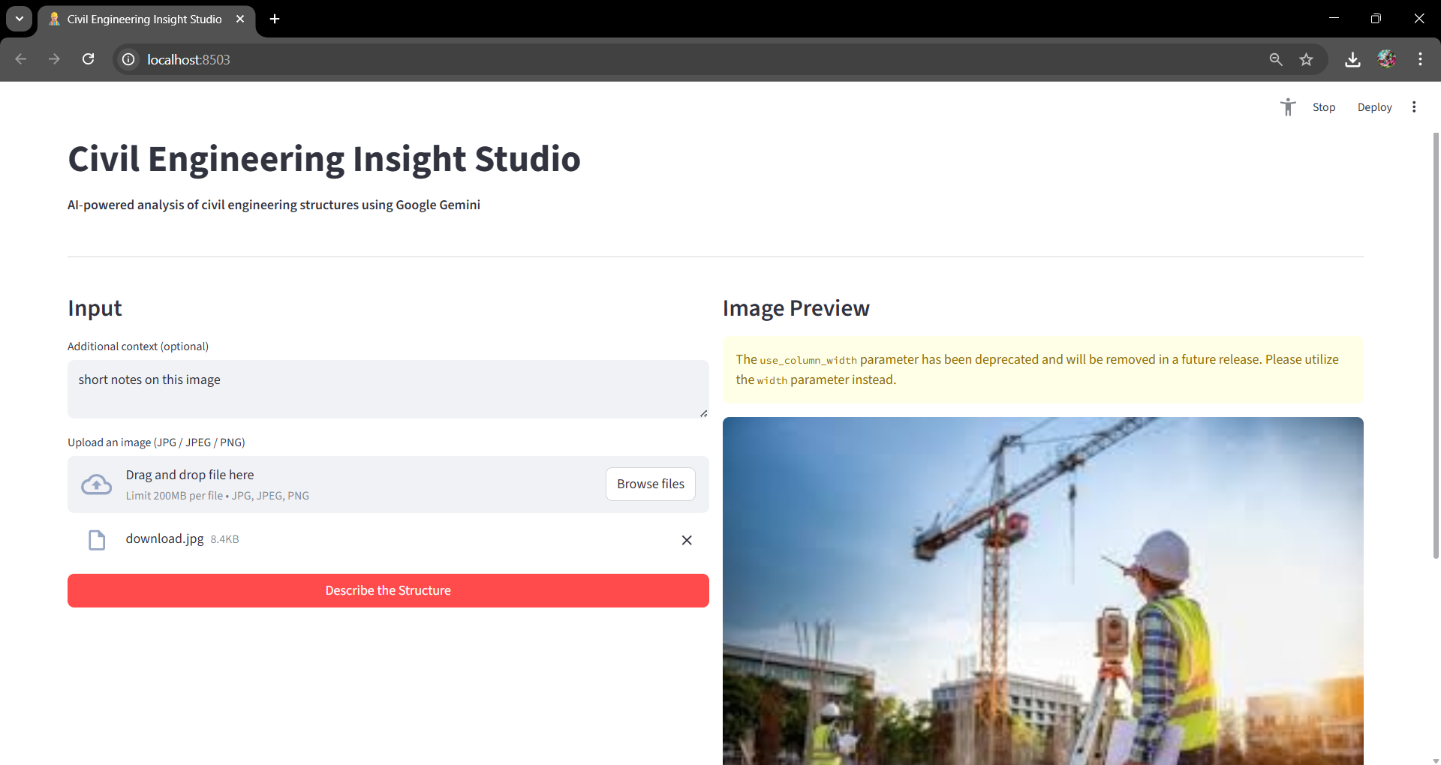

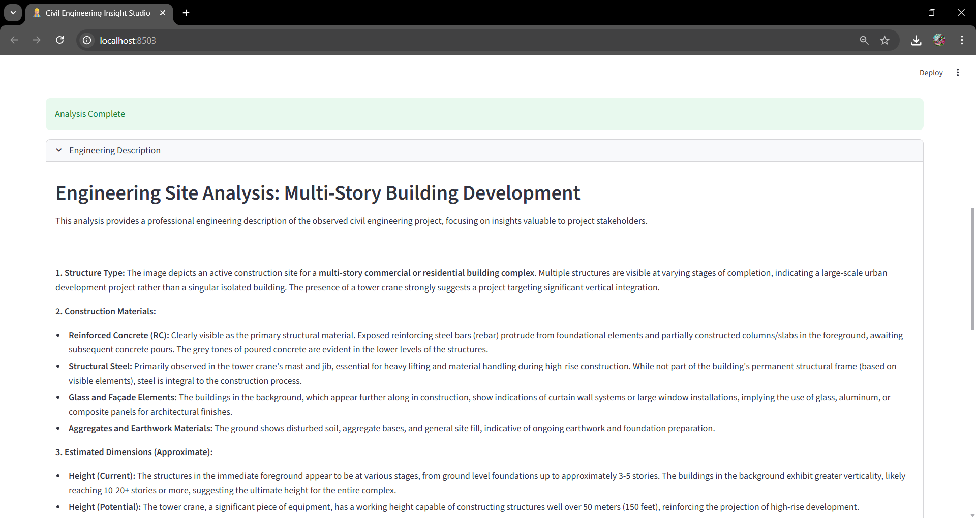

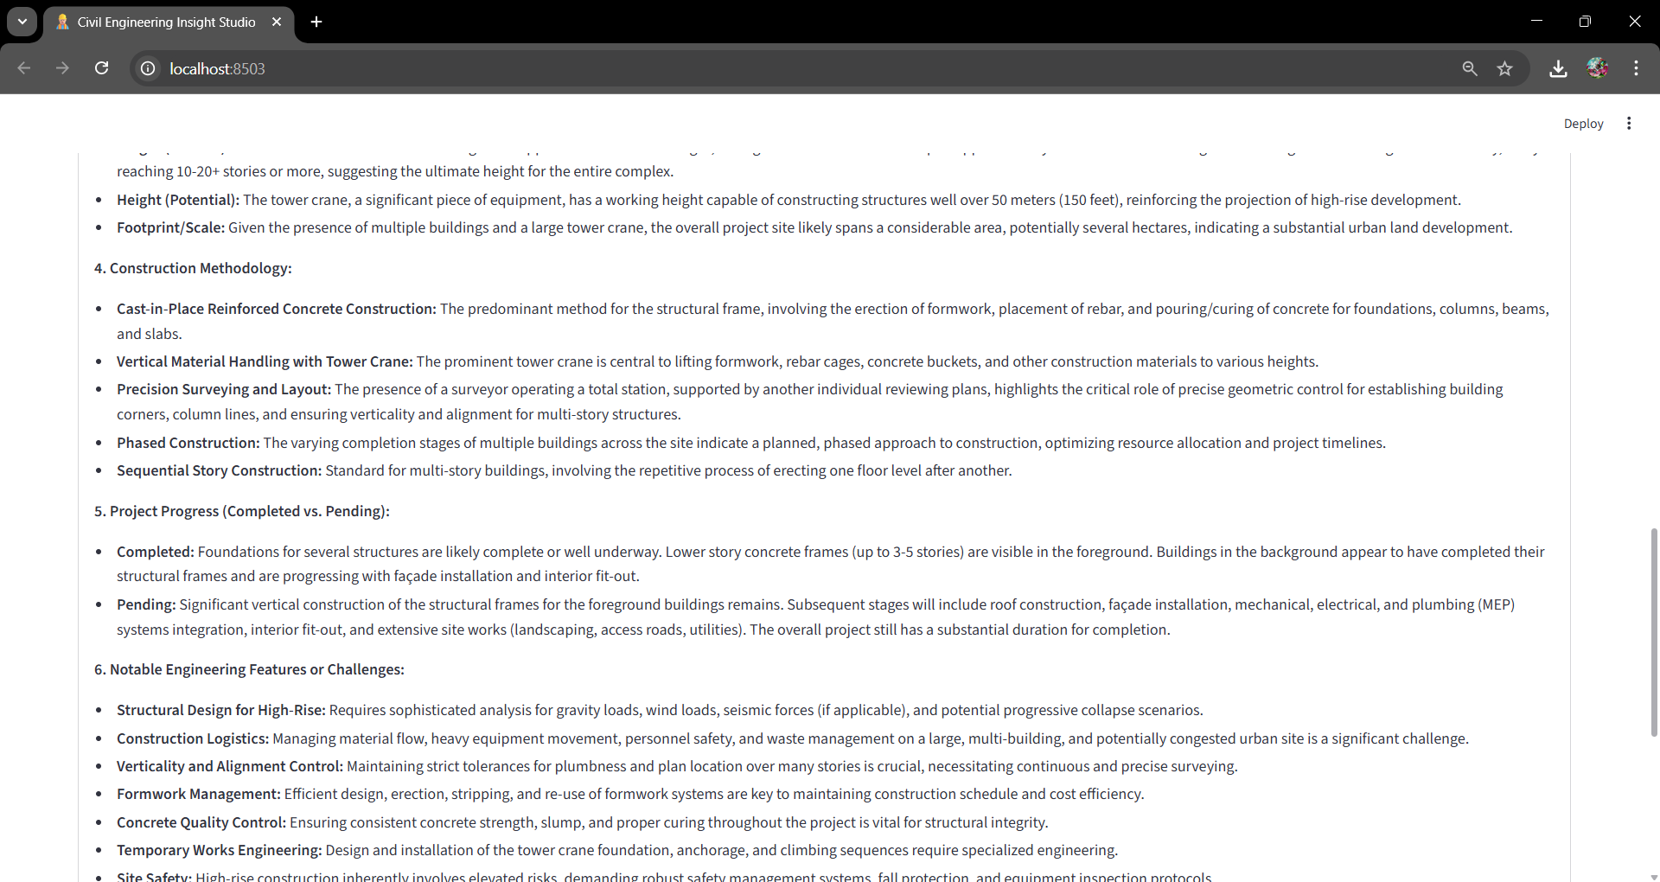

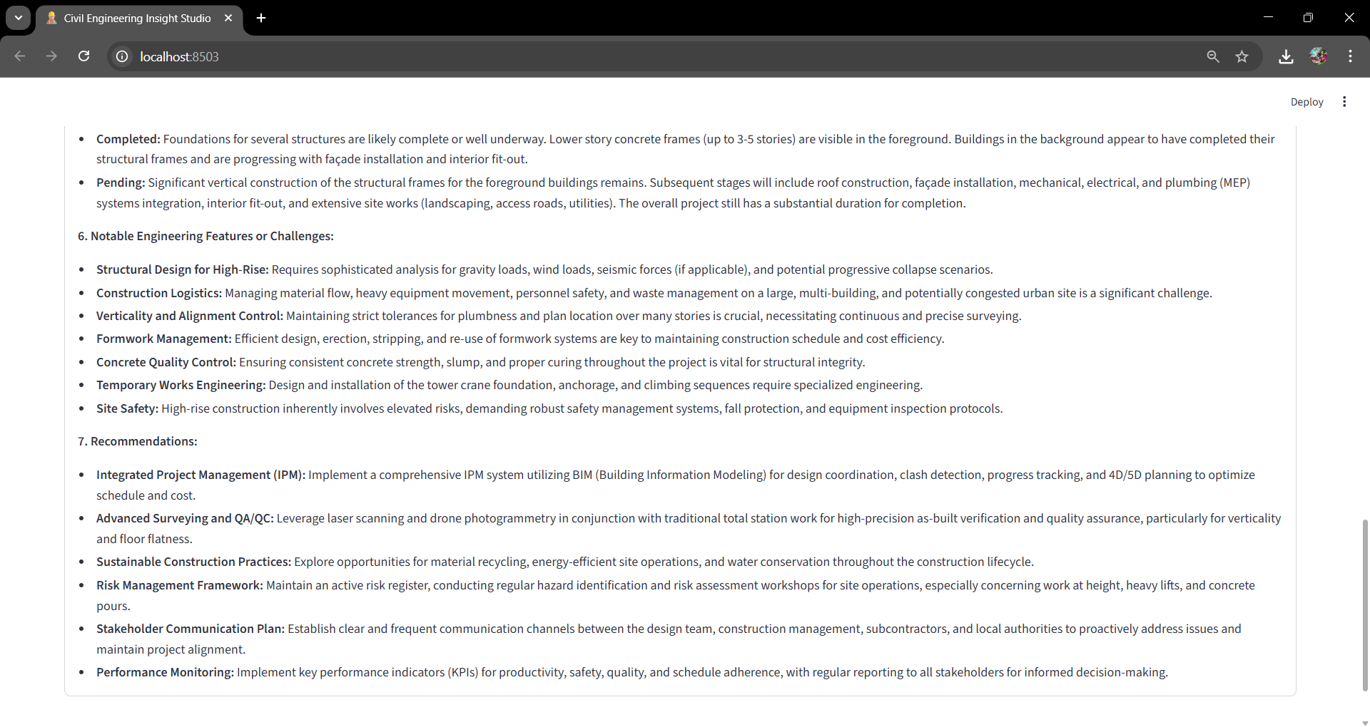

8. ADVANTAGES & DISADVANTAGES

Advantages
Reduces manual documentation effort
Improves reporting speed
User-friendly interface
AI-powered automation
Secure API handling

Disadvantages
Depends on image quality
Requires internet connection
AI estimation is not a replacement for structural calculations

9. CONCLUSION
The Civil Engineering Insight Studio demonstrates how generative AI can transform civil engineering documentation processes.
By integrating image analysis with multimodal AI capabilities, the system enhances efficiency, consistency, and communication in construction and structural engineering workflows.

10. FUTURE SCOPE
- BIM integration
- PDF auto-report generation
- Multi-image comparison
- 3D structural modeling
- Damage detection module
- Load estimation analytics

11. APPENDIX

Source Code
https://drive.google.com/drive/folders/1wtXTm69V1rxn9t7yiZYl8cONQBkAkdXt?usp=sharing
Main components:
- API initialization
- Image processing function
- Gemini response function
- Streamlit UI integration
Image links:

https://drive.google.com/file/d/1pHnuhTHAVhnzhotMaVmRorMKkp7Ptv8l/view?usp=sharing

https://drive.google.com/file/d/13A3SMqWGZsKWHLWz0va2e9qCwfXC_fZI/view?usp=sharing

Dataset Link
This project does not use a predefined dataset.
Images are provided dynamically by users.

GitHub & Project Demo Link
GitHub Repository: https://github.com/nandhu-2514/Civil-Engineering-Insights-Studio
Project Demo: https://drive.google.com/file/d/1vSLeFHYryofow_rPOyAw1HbaGIcVs7-N/view?usp=sharing

